Invoke Bot
Invoke Bot Through Panel
Manage Panel Session
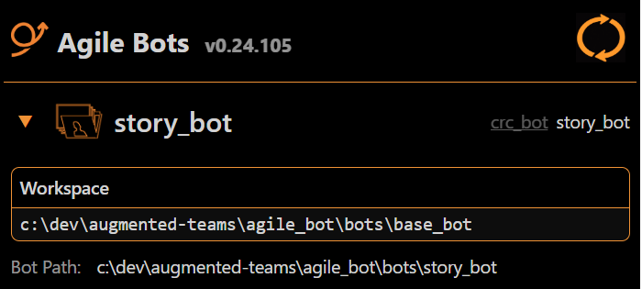

Open Panel
Display Session Status
Change Workspace Path
Switch Bot
Toggle Panel Section
Navigate And Execute Behaviors Through Panel
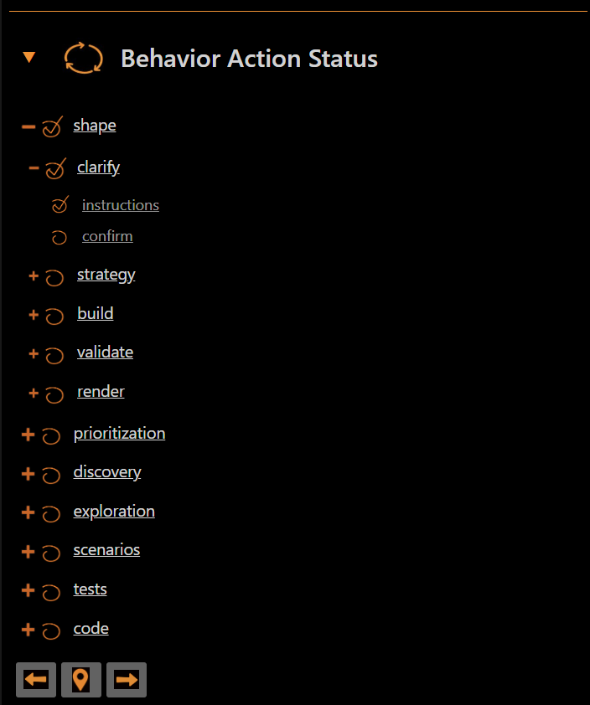
Display Hierarchy
Navigate Behavior Action
Execute Behavior Action
Manage Scope Through Panel

Filter Story Scope
Display Story Scope Hierarchy
Filter File Scope
Open Story Files
Display Action Instructions Through Panel
Display Base Instructions
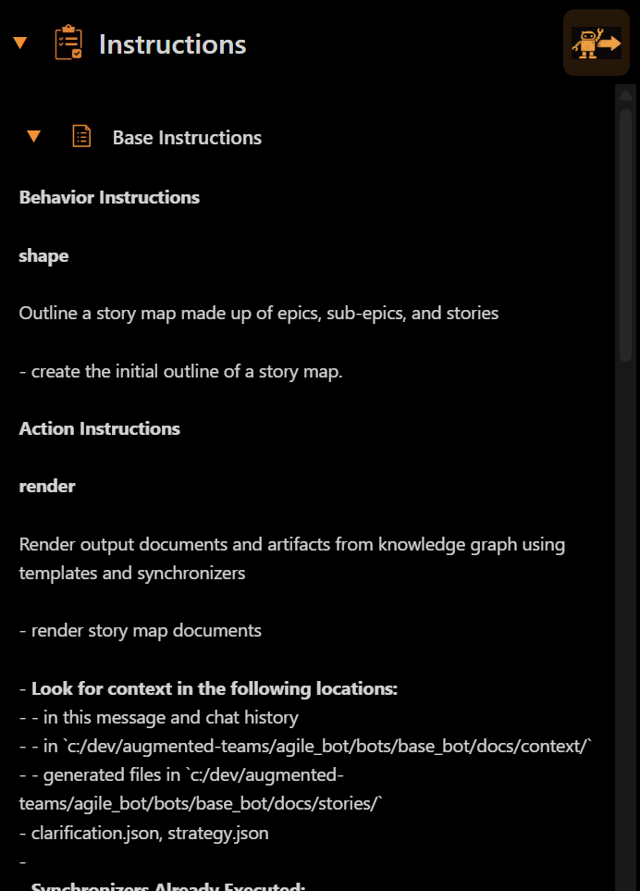
Display Clarify Instructions

Display Strategy Instructions

Display Build Instructions
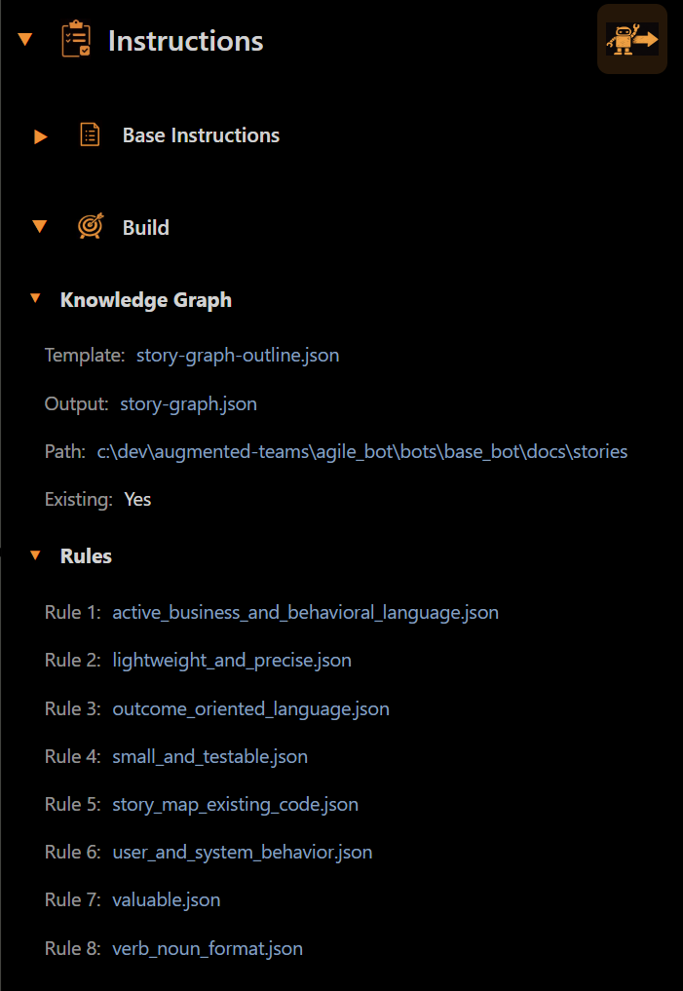
Display Validate Instructions

Display Render Instructions

Display Instructions In Raw Format
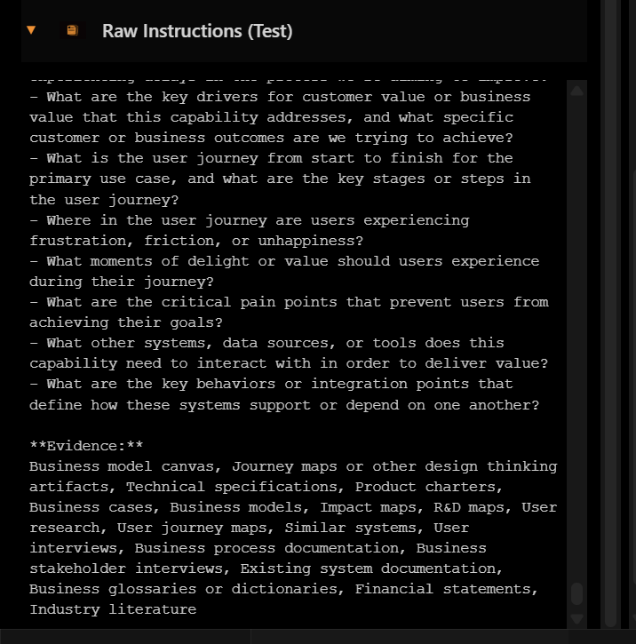
Submit Instructions To AI Agent

